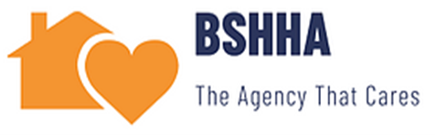
Accounts Payable Direct Deposit Authorization Form

For Employee Payroll and Expense Reimbursements

Return this completed form and appropriate attachments to Payroll Department @ 922 Gates Avenue, 2nd Floor Brooklyn, NY 11221.

 | Employee: | New Enrollment □ |  | Change Existing Information □
 | Employee/Student Name |  | ID#:
 | Home Address:
 |  |  | Telephone Number:
 |  |  | Email: (for remittance information)

Bank Information:

For a checking account, include a blank voided check or bank statement indicating the ACH routing number and account number. For a savings account, include a statement from your bank indicating the ACH routing number and account number.

A deposit form will not be accepted as proof of routing number or account number.

Account Type (check one): Savings □ or Checking □ Bank Name

Branch Address City State _ Zip

Your ACH routing number appears at the bottom of your checks between the markings indicated below.

ACH Routing Number (first 9 digits only) Account Number

AUTHORIZATION AGREEMENT

I authorize Bushwick Stuyvesant Heights Home Health Care Attendants to make electronic deposits of payments indicated in section 1 above. This authority will remain in effect until I have given written notice of termination or until BSHHA has notified me that this service has been discontinued. In the event of changes to my information, I understand that I must give advance notice to allow reasonable time for my instructions to be executed. In the event that an incorrect amount should be entered into my account, I authorize my bank and BSHHA to make the appropriate adjustment. If you provide either avoided check or a bank statement verifying your ACH routing and account numbers, deposits will take effect with the payment processed. If no voided check or bank statement is provided then your Direct Deposit agreement will become effective after approximately two weeks. A check will be issued until the agreement takes effect.

 | Employee/Student Signature |  |  |  | Date

